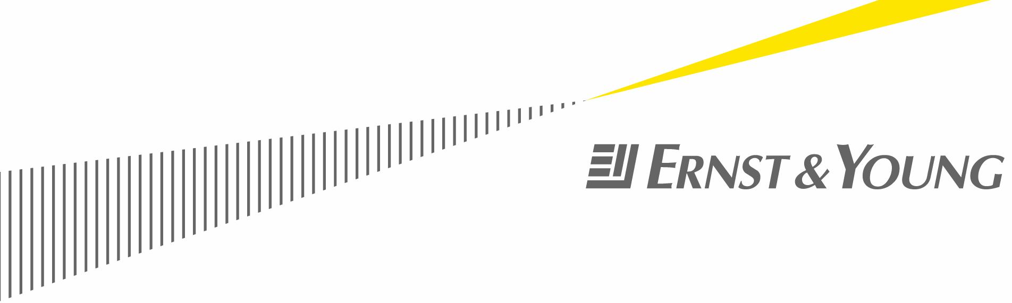

[Product name]
- Product Vision and Scope
  - Purpose of document
The purpose of the Product Vision & Scope document is to establish a common understanding of the product vision and consolidate the information known at this time about the product and the business process the technology supports. The product vision will provide the framework for the further development of the product requirements at all levels to ensure the final product satisfies the long-term roadmap for the enabling technology, thus ensuring that individual phases of the technology development will be aligned with the ultimate vision. It focuses on the capabilities needed by the stakeholders and users and why these needs exist. The details of the product needs will be specified in the subsequent requirements documentation during the elaboration phase.
  - Document review and acceptance
Role | Name | Date accepted
  - Revision history
Version | Name | Revision description | Date
v0.1 |  | Initial draft
v0.2
v1.0 |  | Baseline document
- Business requirements
  - Background
[This section summarizes the rationale for the new product or enhancement to an existing product. Provide a general description of the history or situation that lead to the recognition that the product should be built or enhanced.]
  - Business opportunity
[Describe the business problem that is being solved. Describe the business environment in which the product will be used. This may include a brief comparative evaluation of existing products and potential solutions, indicating why the proposed product is attractive. Identify the problems that cannot currently be solved without the product, and how the product fits in with market trends or strategic directions.]
  - Business objectives and success criteria
Key business objectives include:

Success of the product will be defined as follows:
- [Determine how success will be defined and measured on this project, and describe the factors that are likely to have the greatest impact on achieving that success. Include things within the direct control of the organization, as well as external factors. Establish measurable criteria to assess whether the business objectives have been met.]
Success criteria | Value provided | Measurement
  - Business risks
[Summarize the major business risks associated with developing or enhancing this product, such as timing issues, user acceptance, implementation issues, or possible negative impacts on the business and indicate the likelihood of occurrence.]
Known business risks include:
Business risk | Mitigation strategy | Likelihood of occurrence
  - Constraints
Known constraints include:

- Vision of the business solution
  - Vision statement
[Write a concise vision statement that summarizes the purpose and intent of the new product or for enhancing an existing product and describes what the business environment will be like when it includes the new / updated product. The vision statement should reflect a balanced view that will satisfy the needs of diverse customers as well as those of IT Services. It may be somewhat idealistic, but it should be grounded in the realities of existing or anticipated customer markets, enterprise architectures, organizational strategic directions, and cost and resource limitations.]
  - Major features
[State the business and user requirements resulting from the analysis performed in inception. State the requirements for the product by system features, the major services provided by the product.]
[Feature]
[Business requirement ID: State business requirement which is a condition or capability needed by a user to solve a problem or achieve an objective.]
- [User requirement ID: State user requirement which is used to describe the tasks the users must be able to accomplish with the system or product.]
- [User requirement ID: State user requirement which is used to describe the tasks the users must be able to accomplish with the system or product.]
[Feature]
[Business requirement ID: State business requirement which is a condition or capability needed by a user to solve a problem or achieve an objective.]
- [User requirement ID: State user requirement which is used to describe the tasks the users must be able to accomplish with the system or product.]
[User requirement ID: State user requirement which is used to describe the tasks the users must be able to accomplish with the system or product.]
  - Assumptions and dependencies
The following assumptions were made when writing the vision and scope document:
- [Note any major dependencies the product must rely upon for success, such as specific technologies, third-party vendors, development partners, or other business relationships.]
- Scope and limitations
  - Scope of current release
[Describe the intended major features that will be included in the release of the product. Consider the benefits the product is intended to bring to the various customer communities, and generally describe the product features and quality characteristics that will enable it to provide those benefits. Avoid the temptation to include every possible feature that any potential customer category might conceivably want some day. Focus on those features and product characteristics that will provide the most value, at the most acceptable development cost, to the broadest community.]
  - Scope of subsequent release
[If a staged evolution of the product is envisioned over time, indicate which major features will be deferred to later releases.]
  - Limitations and exclusions
[Identify any product features or characteristics that a stakeholder might anticipate, but which are not planned to be included in the new product.]

- Business context
  - User classes/characteristics
[Identify the various user classes that you anticipate will use this product. User classes may be differentiated based on frequency of use, subset of product functions used, technical expertise, security or privilege levels, educational level, or experience. Describe the pertinent characteristics of each user class. Certain requirements may pertain only to certain user classes. Distinguish the most important user classes for this product from those who are less important to satisfy.]

User class | Projected number of users | Characteristics | Priority
  - Operating environment
[Describe the environment in which the system will be used and define the major availability, reliability, performance, and integrity requirements. This information will significantly influence the definition of the system’s architecture.
Consider questions such as: Are the users widely distributed geographically or located close to each other? How many time zones are they in? When do the users in various locations need to access the system? Where is the data generated and used? How far apart are these locations? Does the data from multiple locations need to be combined? Are specific maximum response times known for accessing data that might be stored remotely? Can the users tolerate service interruptions or is continuous access to the system critical for the operation of their business? What access security controls and data protection requirements are needed?]
- Analysis models
[Include any relevant analysis models including but not limited to: business interaction models, process flow diagrams, context models, and high-level use case model.]

